Model Description for

**Well water temperature responses to earthquakes: single- and double-aquifer models**

Zhou Bo1, Liu Qiongying1, *, Chen Shunyun1, 2, Yang Zhuzhuan1

1State Key Laboratory of Earthquake Dynamics and Forecasting, Institute of Geology, China Earthquake Administration, Beijing, China

2Xinjiang Pamir Intracontinental Subduction National Observation and Research Station, Beijing 100029, China

* Corresponding author: Liu Qiongying (liuqiongying@ies.ac.cn)

The well-aquifer model was constructed using an axisymmetric simulation with a radius of 500.1 m and a depth of 200 m; and the radius of the borehole was 0.1 m. The temperature at the upper boundary of the model was set to 23°C, with a vertical temperature gradient of 3°C /hm. Both the lateral and bottom boundaries were defined as no-flow and thermally insulated. The top boundary of the well was open. The bottom of the well was set to be permeable or impermeable. The vertical flow velocity and temperature were calculated with an accuracy of 10-6 m/s and 0.1 mK, respectively. Simulations were conducted to calculate water temperature changes over 1 day. The maximum time step was set to 0.1 hour for the first 0.5 days and 1 hour for the remaining 0.5 days.

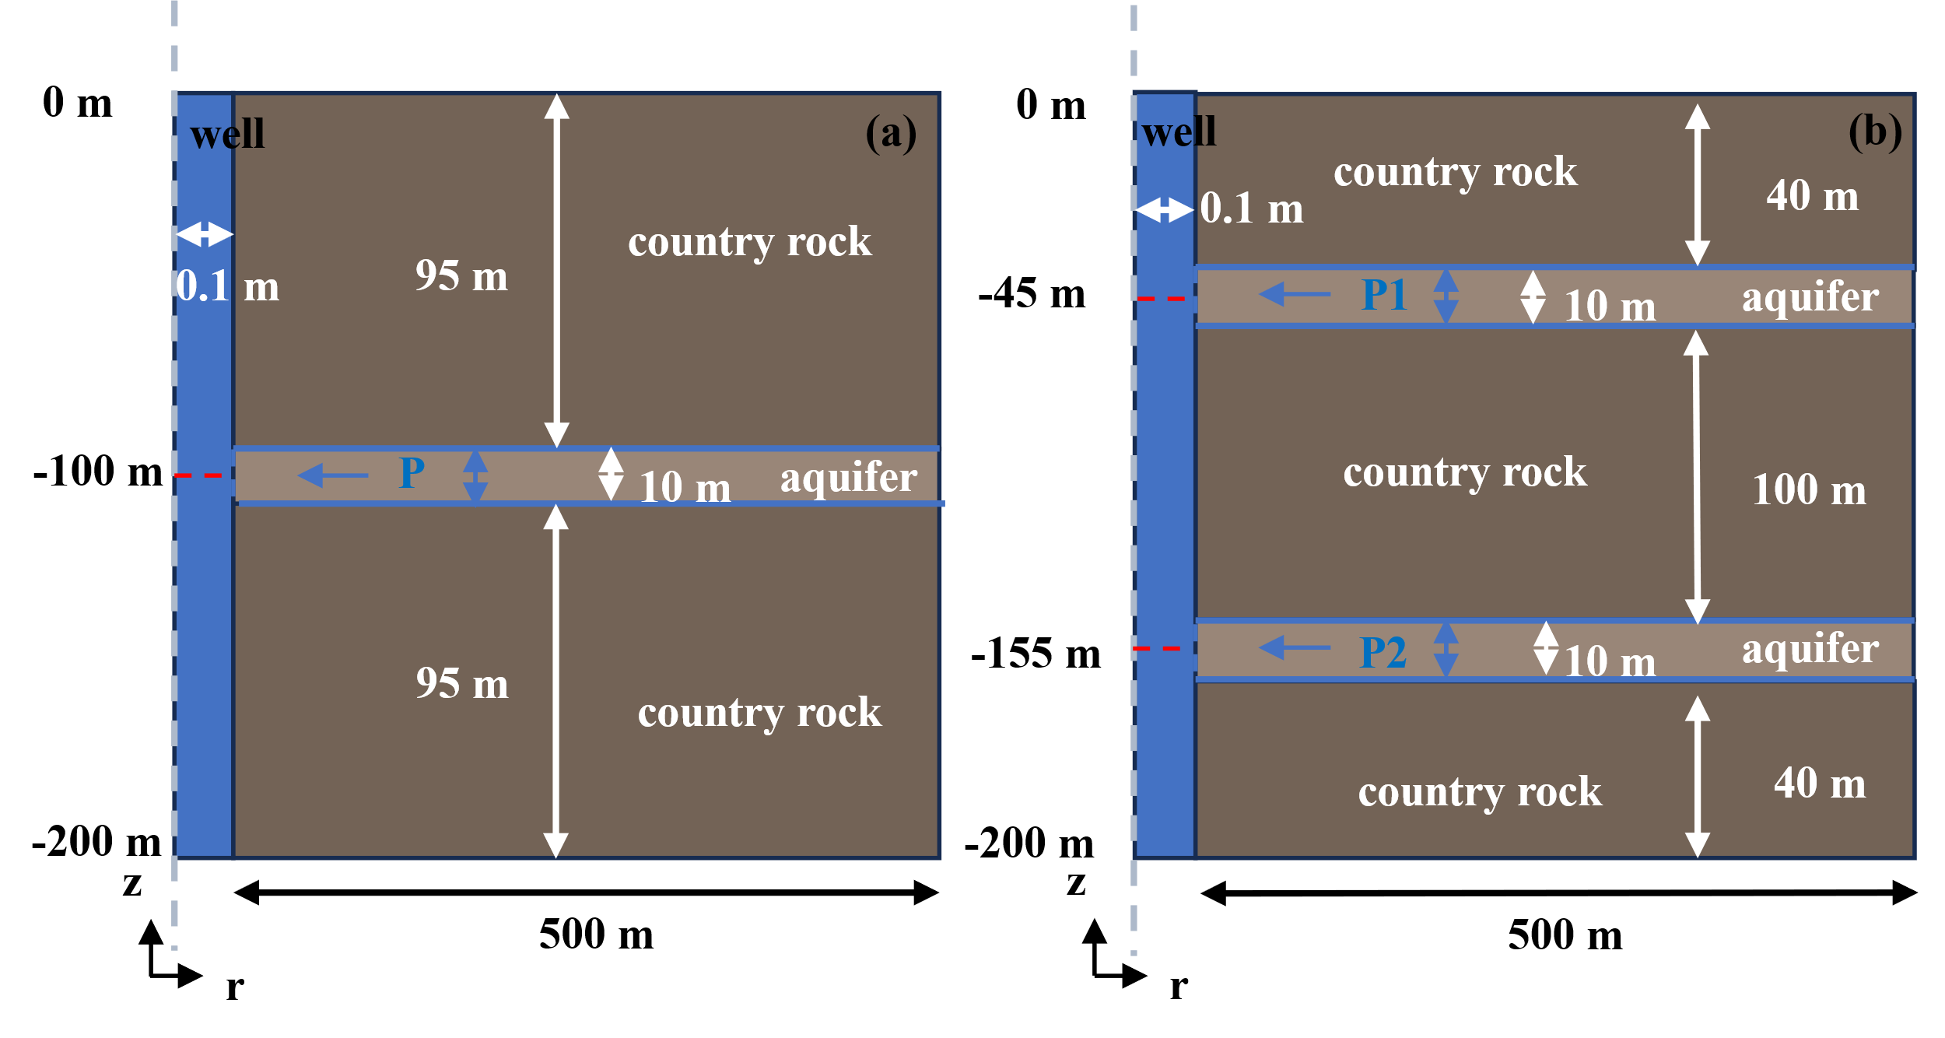

**Figure 1.** (a) Well-single aquifer model and (b) well-double aquifer model.

For all models, the minimum grid division within the borehole is 0.004 m and the maximum is 0.5 m. In order to reduce the calculation time, we adjusted the grid for the aquifers and the surrounding rocks. The maximum and minimum aquifer grid lengths are 0.06–3 m, 0.06–3 m, and 0.01–3 m for the single-, double-aquifer, and Chuan No. 03 well models, respectively. For the country rock grid lengths, the ranges are 3–65 m for both the single- and double-aquifer models, and 5–99 m for the Chuan No. 03 well model.

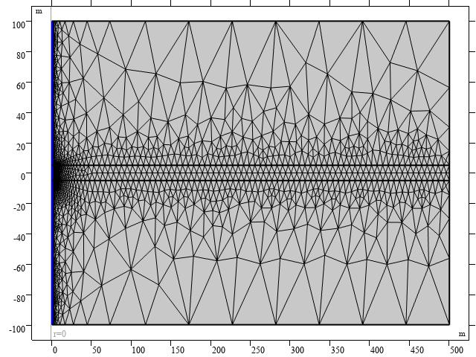

**Figure 2.** Grid division of well single-aquifer model.

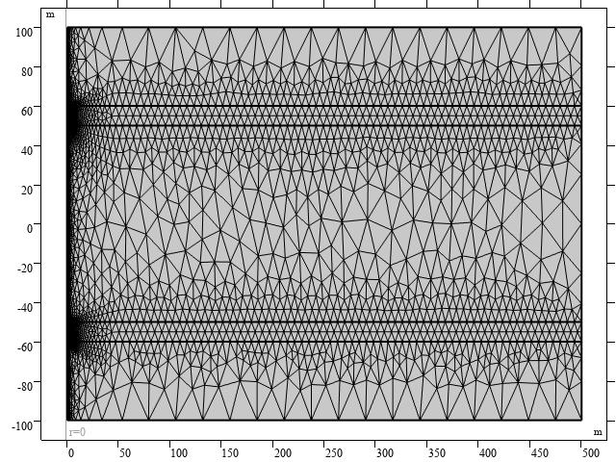

**Figure 3.** Grid division of well double-aquifer model.

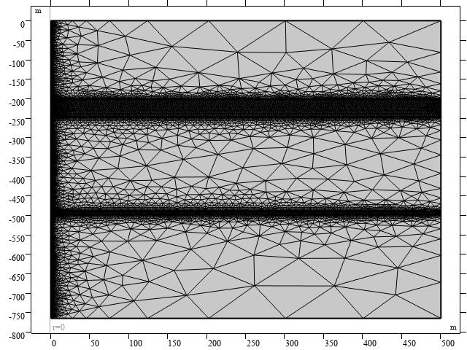

**Figure 4.** Grid division of Chuan No.03 well model.

Changes in pore pressure and permeability are represented in the form of a Gaussian distribution and a step function, respectively.



**Figure 5.** Pore pressure changes of the aquifers follow a Gaussian distribution.



**Figure 6.** Permeability of the aquifers follow a stepwise change.

The thermophysical parameters are listed in Table 1.

**Table 1.** Thermophysical model parameters used for simulation

|  |  |
| --- | --- |
| **Parameter** | **Value** |
| Dynamic viscosity | 0.03 Pa·s |
| Density of water | 1,000 kg/m3 |
| Thermal conductivity of water | 0.6 W/ (m·K) |
| Density of country rock and aquifer | 2000 kg/m3 |
| Initial permeability of country rock and aquifer | 1×10-15 m2 |
| Heat capacity of country rock and aquifer | 900 J/ (kg·K) |
| Thermal conductivity of country rock and aquifer | 3 W/ (m·K) |